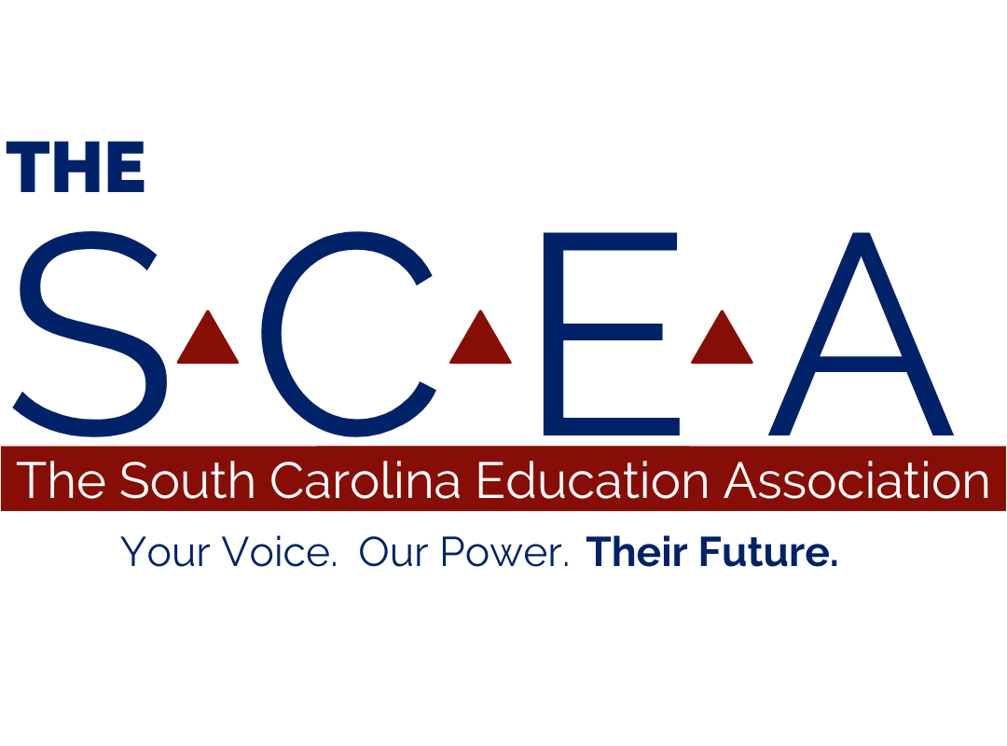

**Legislative Agenda for 2026**

The South Carolina Education Association (The SCEA) believes that a free, high-quality public education is a right of every child. Public education serves as the backbone of our state in ensuring the health of our democracy, development of our economy, and strength of our communities.

To ensure that all children in South Carolina receive the highest quality education, The SCEA recommends that the General Assembly abide by Article XI of the SC Constitution and pursue the following actions:

**Ensure Equitable & Effective Education Funding**

1. **Fully Fund Public Schools**

The General Assembly should ensure equitable opportunities for students of all abilities and post-secondary education pathways. Furthermore, no public money should be used to fund private school vouchers in any form.

* Equitable Distribution of Funds: Public funding must be equitably distributed to ensure that all students-including those with disabilities, students from low-income families, English learners, and students in rural and historically underserved communities-have access to the resources necessary for academic success and post-secondary readiness.
* Addressing funding Disparities Between School Types: The current education funding formula must be revised to eliminate systemic disparities between traditional public schools and public charter schools. While both are publicly funded and serve public school students, they are often funded by different perceived growth mechanisms that result in unequal access to resources. Charter schools and traditional public schools must be held to equitable funding standards to comply with state constitutional and federal obligations.
* Prohibition of Public Funds for Private Education: Public funds must be used solely for public education. The General Assembly should reject all direct and indirect forms of private voucher programs, including tax-credit scholarship schemes that divert public dollars to private or religious institutions and erode the integrity of the state’s public education system.

1. **Tax Abatement Reduction**

South Carolina’s public schools have experienced significant revenue losses due to corporate tax abatements. Between 2017 and 2023, these abatements resulted in a cumulative loss of approximately $3.2 billion for public school districts statewide. In 2023 alone, school districts reported losses of $541 million, up from $326 million in 2017. This trend reflects a growing financial burden on public education, with per-student losses increasing from $448 in 2017 to $727 in 2023.

Notably, Berkeley County School District has been among the hardest hit, averaging over $70 million in annual losses since 2017. In 2023, Spartanburg School District 5 reported losses exceeding $100 million, while Charleston County School District faced losses of $207 million over the same period. These substantial reductions in funding have direct implications for educational resources, staffing, and student support services.

To address these challenges, The SCEA recommends the following legislative actions:

* Revenue Sharing: Mandate that school districts be held harmless on tax abatement benefits granted to businesses, ensuring that educational institutions share in the economic development they help support.
* Inclusive Decision-Making: Require that school district representatives have a formal role in negotiations and agreements related to tax abatements, providing them with a “seat at the table” to advocate for educational interests.
* Accountability Measures: Implement stringent accountability protocols to ensure businesses comply with the terms of their tax abatement agreements, including performance metrics and claw-back provisions for non-compliance.
* Time-Limited Incentives: Establish reasonable time limits on tax abatements to minimize prolonged revenue losses for public schools and encourage timely contributions from benefiting businesses.

By enacting these measures, the General Assembly can help mitigate the adverse effects of corporate tax abatements on public education funding and promote a more equitable distribution of resources across South Carolina’s school districts.

Legislation to exempt schools and school operations from tax abatements must be adopted. The SCEA suggests the following to alleviate the loss of revenue to our schools:

* School districts should receive 20% of the tax abatement profits from the businesses to whom they are provided.
* School districts/educators should have a “seat at the table” when the tax abatement agreements are made with prospective businesses.
* Accountability to the tax abatement and the stipulations should be required to ensure the businesses are complying with the agreement.
* There should be a time limit for tax abatements that are reasonable, allowing less revenue loss for public schools.

1. **Fund the Outcome for Career and College Readiness Pathways**

To foster life and career characteristics, the General Assembly must fully fund a broad, well-rounded curriculum that includes vocational training, dual credit opportunities, and liberal arts instruction. All students in South Carolina deserve equitable access to educational pathways that include not only STEM and workforce readiness but also the humanities, arts, social sciences, and languages, which are essential to cultivating critical thinking, creativity, communication, and cultural literacy.

Providing access to liberal arts education ensures students are not narrowly tracked but instead prepared to adapt, lead, and contribute to a rapidly evolving democratic society and global economy. opportunities for students to pursue vocational learning and dual credit coursework to ensure they graduate ready for post-secondary education pathways.

1. **Prioritize the Classroom**

To maximize teacher effectiveness, state funding should be prioritized to:

* Reduce class sizes and caseloads by at least 10 to promote individualized instruction.
* Provide all South Carolina educators with both daily duty-free lunch and uninterrupted daily instructional planning time **without adding minutes to the regular school day**.
* Provide all students, educators, and school staff in South Carolina with equal and reliable access to support services. All students and staff must have equitable access to licensed mental health professionals; school counselors and social workers; instructional coaches and interventionists; and school nurses. These services must be consistently available on-site, not rotating among multiple campuses, to meet health, safety, and learning needs. The state should fund enough staff to meet a 1:250 counselor-to-student ratio, in line with the American School Counselor Association recommendation.
* Continue to increase the classroom supply fund and establish a statutory requirement that this fund be indexed annually to inflation (using CPI or another standard index), ensuring that educator purchasing power does not diminish over time.

**Respect Educators as Professionals**

1. **Provide Competitive Compensation**

The charge of the General Assembly is clear. Ensure that South Carolina’s students get the best educators in their classrooms. To do this, the General Assembly must recognize they are competing for workers in the overall job market. A fully funded investment in raises to a minimum of $50,000 for all teachers and a minimum of $36,000 for all support staff must be made. To remain competitive in this overall job market and retain and attract educators in South Carolina public schools, the General Assembly needs to increase pay yearly at a rate that accomplishes the following:

* Raises pay for all educators that target the cost of living in the areas that live and work as a function of their take home pay beginning with $50,000 for first year teachers and $36,000 for support staff.
* Raise pay for all educators at a rate with the target to lower the number of teaching vacancies, Districts that are hard to staff should increase pay statewide at the beginning of the 2025-26 school year. (Current estimates from CERRA have 1,042 vacancies.)
* Ensure that state benefits are competitive against other industries in the state.
* Additionally, the state must ensure that districts fairly compensate all educators for administrative paperwork, training, meetings, and extracurricular activities that could risk breaching the agreed 190 days of work.
* Raise the pay of all ESP staff to research market levels for their position in the area to ensure lower vacancies and ensure retention of staff.

1. **Increase Unencumbered Time**

Education Support Professionals should receive sufficient unencumbered time without being given more hours in the day or overall, longer workday. Teachers must be provided with unencumbered time during the school day. Unencumbered time should not be scheduled at the beginning of the day prior to teachers “report in” time or after school “clock out” time.

1. **Reduce Burdensome Paperwork**

Districts should report/review/audit the workload of any new system and/or program to ensure that it does not breach the 190-day contract for any teacher without compensation for that extra time defined.

1. **Produce a Fair and Equitable Contract**

Contract clarity and reasonable flexibility are essential to keeping skilled educators in the profession. Teacher contracts must become more equitable for educators. While many issues in teacher contracts need to be addressed, the following must be included:

* **Transparent Terms:**
* A later contract acceptance date when educators are offered reemployment by their district, they must accept that offer before May 10, before the district determines staffing assignments for the coming year and certainly ahead of any updated information regarding pay for the upcoming year. Educators should be given a grace period to be released from their contract to make the right decision for themselves and their families without fear of reprisal.
* Educators need to understand the compensation and benefits they are accepting and who maintains and adjusts their benefits. Contracts must be required to clearly outline all benefits and compensation provided, clearly delineating which benefits are provided by the district and which are provided by the state and how the educator accepting the contract may find more detailed information about each benefit.
* The number of days worked per year, the daily hours, the years’ experience, the worksite, and subject taught.
* **Grace Periods and Contract Clarity:**
* The right to break a contract without penalty in a ten-day window when informed of pay, worksite, and/or teaching subject change. When educators are offered reemployment by their district, they must accept that offer before contract signing date — often before the district determines staffing assignments for the coming year and certainly ahead of any updated information regarding pay for the upcoming year. Educators should be given a grace period to be released from their contract to make the right decision for themselves and their families without fear of reprisal.
* **Workload Protections and Right to Refuse Uncompensated Labor:**
* Teachers need to be given the opportunity to refuse in writing when administration or district give “other duties assigned” that are arguably unreasonable due to issues including but not limited to breaching the agreed 190 days of work, personal responsibilities (such as lack of childcare), and having to purchase goods out of pocket (bake sales). Districts need penalties for retaliation against teachers that provide documentation of refusal.

1. **Improve Teacher Recruitment & Retention Programs**

The state should incentivize teacher commitments to hard-to-staff regions by:

* Paying off teacher student loan debt to encourage teacher relocation.
* Providing home payment assistance and/or home purchasing programs for educators.
* Rewarding teachers with state-funded service using longevity pay for consecutive years of work in those school districts.
* Identifying mentorship programs that are successful and implementing them in our state by the school year August 2026.
* The General Assembly must find more ways to increase and retain the pool of highly trained educators in South Carolina. For recruitment, this must include paying student teachers for their student teaching experience; and expanding and funding a “grow your own” educator pathway.
* Increasing support of early career educators through a well-funded and respected mentorship program.

1. **Trust Educators as Education Experts**

The General Assembly should seek to protect the relationship and community between parents, educators, and schools and to respect the frontline expertise of educators by refraining from passing any legislation that limits what history our children can learn and what books they can read. In addition, educators should have the freedom to teach the honest, complete facts about historical events without political censorship, undue scrutiny, or top- down bureaucratic policies and processes that impede timely, natural communication between educators and parents. The control of the implementation of the state standards should be trusted in the hands of the state department of education and the local school system.

1. **Provide Comprehensive Benefits**

The General Assembly must adopt legislation providing a comprehensive range of benefits for South Carolina’s public-school educators.

* The legislation should provide school staff who adopt a child or who are licensed by the Department of Social Services and have a foster child placed in their care eligible for two state funded paid weeks’ leave.
* The legislature should maintain the benefits for all educators by funding the current defined-benefit retirement plan and extending a health benefit that includes affordable enhanced dental, vision, hearing, and prescription drug coverage.

**Provide an Education of Excellence**

1. **Increase Learning Time**

The state should eliminate all non-mandatory testing and explore applying for a flexibility waiver to further reduce those tests that are required by federal law. Educators should be given the highest possible degree of autonomy to select the best way to authentically measure student growth.

1. **Invest in Student and Educator Wellness**

The legislature must fund and take action to get mental health resources to families and caregivers, as well as fund training for educators and school staff to talk to students about awareness of their feelings and signals of mental health problems. The state should make serious investments in programs and curricula that encourage the development of holistic wellness and that encourage the destigmatizing of mental health issues. The state should also partner with local mental health professionals to provide on-site mental health care services for students, educators, and school staff.

The legislature must provide funding for public schools for counselors and social workers at a ratio of 250:1, the ratio most recently recommended by the American School Counselor Association and the National Association of Social Workers.

1. **Invest in School Safety**

The legislature should create a policy requiring schools to file a safety plan with the school district and with the South Carolina Department of Education. The General Assembly must support common sense gun reforms and implement research-based policies to proactively prevent gun violence in our communities and schools. The General Assembly should also support the respectful treatment of all students in creating a safe learning environment free from any bias

1. **Invest in Early Childhood Literacy**

The General Assembly must provide state funded universal 4K to all students to ensure their opportunity to enter kindergarten and elementary school with the skills and background needed to be successful readers and learners.