The SCEA 2026 ELECTIONS
CANDIDATES’ PROFILES

THE SCEA DISTRICT DIRECTOR CANDIDATES

UniDistrict 1 (1-year term: 2026-2027)
(Abbeville, Anderson, Cedar Springs, Greenville, Laurens, Oconee, Pickens, Spartanburg)

Juanita Addison


School: Cherrydale Elementary School. Number of years of membership in the UEP: Five consecutive years of membership in the United Education Profession. Educational Background: Bachelor’s Degree in Elementary Education; Associates in Arts; Associate’s in Science. Work Experience: Special Education teacher at Cherrydale Elementary School; ESP at Cherrydale Elementary School; custodian at A.J. Whittenburg. Professional Association Memberships: The SCEA-Regional Contact Team; member organizer and building representative; Representative Assembly. Platform: I am a special educator in Greenville County Schools with 10 years of service in South Carolina. I am committed to inclusive, culturally responsive instruction and to creating learning environments where every child feels valued. Colleagues describe me as a bridge-builder who listens deeply and leads with integrity. As a candidate for The SCEA District Director, I aim to strengthen educator advocacy and help all schools truly thrive.

UniDistrict 2 (3-year term: 2026-2029)
(Cherokee, Chester, Chesterfield, Darlington, Fairfield, Kershaw, Lancaster, Marlboro, Union, York)

Veronica Thomas
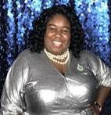
School: Fairfield Central High School and Fairfield County Adult Education Center. Number of years in the UEP: Three consecutive years of membership in the United Education Profession. Educational Background: Francis Marion University (Bachelor of Arts (Major-Mathematics, Minors-Physics/English); Western Governors University-Master’s in mathematics. Work Experience: Fairfield County Adult Education Program Coordinator; STEAM Early College Academy/Dual Enrollment/FC2 Programs Director; Mathematics Educator/ Adjunct Professor. Professional Association Memberships: Fairfield County Association President; SC Alliance of Black School Educators; South Carolina Mathematics Association of Two-Year Colleges. Platform: As District Director, I will prioritize teacher recruitment and retention by implementing innovative practices, strong support, and meaningful professional development to help SC teachers grow and stay. I will advocate for equitable opportunities for all students and staff and ensure resources match their needs. By fostering community partnerships, I will create a collaborative environment where educators, families, and organizations work together to support student success and strengthen our schools. Let’s foster a thriving workplace.
UniDistrict 2 (3-year term: 2026-2029)
(Cherokee, Chester, Chesterfield, Darlington, Fairfield, Kershaw, Lancaster, Marlboro, Union, York)

James R. Fitzpatrick, Jr.
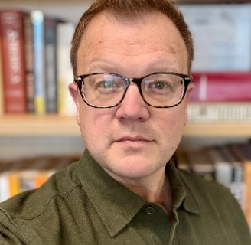
School: Catawba Ridge High School. Number of years in the UEP: Sixteen consecutive years of membership in the United Education Profession. Educational Background: Winthrop University-BA in Political Science and History; Winthrop University-MAT. Work Experience: Hartsville High School (2009-2010)-Darlington School District; Nation Ford High School (2010-2019)-Fort Mill School District; Catawba Ridge High School (2019-present)- Fort Mill School District (served as a social studies teacher at each; predominately as an AP US History teacher. Platform: With sixteen years of classroom experience, district-level leadership roles, and service as a certified evaluator, I believe public education is the cornerstone of a healthy democracy. I’m running to ensure educators’ voices guide decisions that shape our schools. I will advocate for fair working conditions, transparent communication, and strong support for students and staff. My commitment is to represent members with integrity, elevate their concerns, and strengthen our shared professional community.

UniDistrict 2 (3-year term: 2026-2029)
(Cherokee, Chester, Chesterfield, Darlington, Fairfield, Kershaw, Lancaster, Marlboro, Union, York)

Dr. Erika Patterson


School: York Comprehensive High School. Number of years in the UEP: Thirteen consecutive years of membership in the UEP. Educational Background: University of South Carolina-Doctor of Education in Curriculum & Instruction; Winthrop University-M.A. English Lit; M.A.T. Secondary English; B.A. English Lit; United Theological Seminary of the Twin Cities-Doctor of Ministry in Public Theology (ABD. Work Experience: York Comprehensive High School; York Technical College; York Middle School. Professional Association Memberships: National Council for Teachers of English; National Education Association &The SCEA; York County Vice-President for YSD1; South Carolina State Guard-Chaplain Unit-Religious Specialist. Platform: Education for all students, no matter their faith, gender and abilities, is fundamental to those we serve. Supporting educators in public schools is necessary for an equitable education, which should reflect tolerance and acceptance for their differences, beliefs, practices, and identities. As an educator, chaplain, and South Carolina Guard soldier, I plan to use my skills to help my fellow educators navigate ou r educational
system to assure they are treated with equity, tolerance and acceptance.

UniDistrict 2 (3-year term: 2026-2029)
(Cherokee, Chester, Chesterfield, Darlington, Fairfield, Kershaw, Lancaster, Marlboro, Union, York)

Erica Knox
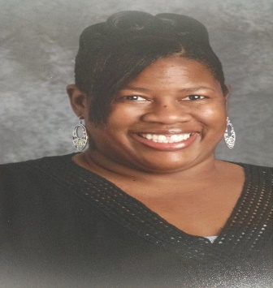

School: Rock Hill High School. Number of years in UEP: Twenty-two consecutive years of membership in the United
Education Profession. Educational Background: York Technical College-Customer Service Certification. Work Experience: Customer Service; Data Entry; Phone Etiquette. Professional Association Memberships: Education Support Professionals-Chairperson; Vice President-York County Education Association; Team Lead-Campaign Lab (NEA-York County Education Association. Platform: I like networking with others. I am one of the top recruiters for The SCEA, I am Team Lead for Campaign Lab at York County Education Association; chairperson for education support professionals, a member organizer, and regional contact team lead for York County Education Association. I would like to continue my work as District Director for our UniDistrict. I Solicit your vote!

UniDistrict 6 (3-year term-2026-2029)
(Berkeley, Charleston, Clarendon, Dorchester, Georgetown, Lee, Summerville, Sumter, Williamsburg)

Kathleen Low


School: Hanahan High School. Number of years in the UEP: Three consecutive years of membership in the United Education Profession. Educational Background: College of Charleston- B.S. in Physics; University of South Carolina-MAT-Physics. Work Experience: Teacher-Wando High School; Lab Manager/Instructor, Physic Department,-College of Charleston; Teacher-Hanahan High School. Professional Association Memberships: BCEA President, The SCEA Legislative Chair. Platform: As a physics and earth science teacher, I bring a classroom-centered perspective to union leadership. As President of the Berkeley County Education Association and Legislative Chair for The South Carolina Education Association (The SCEA), my work is focused on educator retention, fair contracts, and professional respect. I
believe strong schools depend on strong working conditions for educators, and I am committed to advancing policies that protect teachers, strengthen the profession, and improve student outcomes.

UniDistrict 6 (3-year term-2026-2029)
(Berkeley, Charleston, Clarendon, Dorchester, Georgetown, Lee, Summerville, Sumter, Williamsburg

Kiyanna Mullins
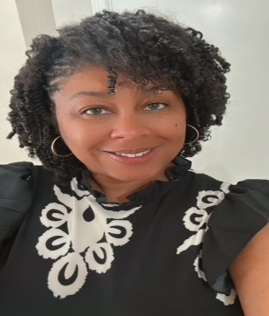

School: Alston Middle School. Number years of in the UEP. Three consecutive years of membership in United Education Profession. Educational Background: University of Phoenix, M.Ed.-Elementary certified; University of Phoenix, B.S.-Communications. Work Experience. Middle level ELA/SS Teacher-Alston Middle School, Dorchester District Two -2020-present; Elementary level teacher (3-5th grade) -Sanders-Clyde Elementary, Charleston County; Elementary and R.T.A. Instructional Assistant (K-5)-Killian Elementary, Richland School District Two (2010-2013). Professional Association Memberships: The SCEA, NEA Resolutions Committee Representative for The SCEA; Human & Civil Right Committee Co-Chair; State lead member organizer; local VP of the Summerville Education Association. Platform: I am committed to advocating for safe, supportive working conditions, elevating members voices through consistent engagement, strengthening local associations with hands-on leadership support, and improving transparency across our district. As District Director, I will be present, responsive, and collaborative—ensuring educators’ needs guide our priorities and decisions, and that every member feels informed, represented, and supported.

UniDistrict 7 (3-year-term- 2026-2029)
(Allendale, Bamberg, Barnwell, Beaufort, Colleton, Hampton, Jasper. Orangeburg)

Dr. Chanell Harris
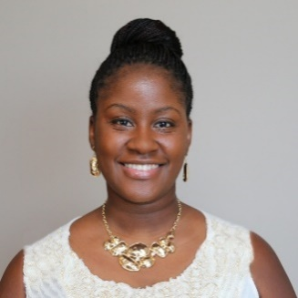
School: Right Choices/Beaufort County. Number of years in the UEP: Seven consecutive years of membership in the UEP. Educational Background: Northeastern University-Doctor of Education-Curriculum, Teaching Leading, and Learning; South Carolina State University-Bachelor of Arts-History/Social Studies Education. Work Experience: South Carolina Department of Juvenile Justice; South Carolina Virtual Charter School, Bythewood High School. Professional Association Memberships: NEA Global Learning Fellowship-participant, mentor; South Carolina Council of Social Studies; South Carolina Council for African American Studies. Platform: As a student member of The SCEA, I was surrounded by passionate educators, active and retired. I watched rooms filled with educators voicing their concerns and truths, fighting for our children and their colleagues. I want to continue the journey that I’ve witnessed. Applying what I have learned in UniDistrict 5 can help build a bridge to state networks for Beaufort County and surrounding areas. We must support our educators if we desire a prosperous future.

CANDIDATES FOR NEA DELEGATES CERTIFIED/NONCERTIFIED

Yolanda Smith
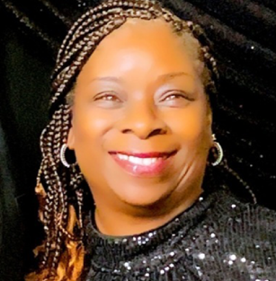

School: Office of Federal and State Programs (assigned to Dreher High School, Hand Middle School and Heyward Career and Technology Center). Number of Years in the UEP: Two consecutive years of membership in the United Education Profession. Educational Background: Benedict College-B.S. Degree in Child and Family Development. Work Experience: Parent and Family Engagement Specialist; Triple P Program (Positive Parenting Program) Practitioner; Parents as Teachers Educator. Professional Association Memberships: Richland County Education Association-secretary, The SCEA-Building Representative (3 locations), and Mobile Organizer.

Kathleen Low
(see information under UniDistrict 6)

Jacqueline W. Simmons
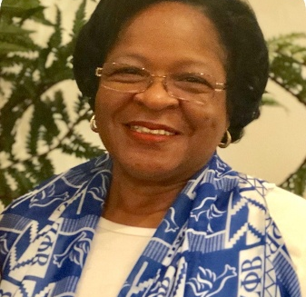

School: Kenneth Gardner Leadership Academy. Number of years in the UEP: Twenty-five plus years of membership in the United Education Profession. Educational Background: Grand Canyon University-Education Leadership; Cambridge College-Master of Education in Elementary Education; Francis Marion College, BS-Elementary Education. Work Experience: Kenneth Gardner Leadership Academy, Williamsburg County-present; Hemingway Elementary, Williamsburg County-classroom teacher; Battery Park Elementary School, Williamsburg County, classroom teacher. Professional Association Memberships. Zeta Phi Beta Sorority, President; Williamsburg County Education Association, President.

Dr. Chanell Harris
(see information under UniDistrict 7)
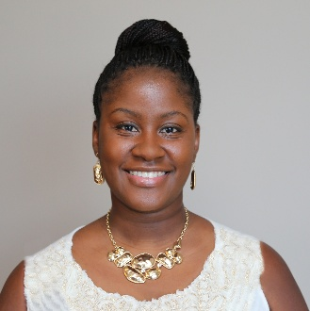

Dr. Erica Patterson
(see information under UniDistrict 2)

Veronica Thomas
(see information under UniDistrict 2)

Joyce B. Argo
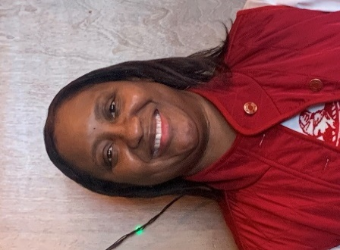

School: Ebenezer Avenue Elementary School. Number of years in the UEP: Twenty-five consecutive years of membership in the United Education Profession. Educational Background: M.Ed in Educational Leadership and Supervision-Winthrop University; M.Ed in Reading/Literacy-Winthrop University; BS in Elementary Education-Winthrop University. Work Experience: Rock Hill School District-Ebenezer Avenue Elementary School; York School District One-Jefferson Elementary School; Lancaster County School District-J.J. Clinton Elementary School. Professional Association Memberships: The SCEA Executive Board of Directors-UniDistrict 2 Director; The SCEA Human and Civil Rights Committee Co-Chair; Rock Hill Alumnae Chapter of Delta Sigma Theta Sorority, Incorporated (immediate past chaplain, immediate past chair of Rituals and Ceremonies Committee and immediate past Executive Board member.

Kiyanna Mullins
(see information under UniDistrict 6)

Dr. Karen Greene
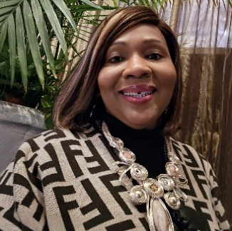
School: Stratford High School. Number of years in the UEP: Seventeen plus years of membership in the United Education Profession. Educational Background: Bachelor’s Degree-Charleston Southern University; Master’s degree-Charleston Southern University; Doctorate Degree-Nova Southeastern University. Work Experience: Berkley County School District-20 years; Springfield College (Charleston Campus) 4 years. Professional Association Memberships: Berkeley County Education Association-past president; The SCEA Board member; 1st Secretary-Treasurer and current Vice President-The SCEA.

Desiree P. Smith


School: Olympia Learning Center. Number of years in the UEP. Twenty years of consecutive membership in the United Education Profession. Educational Background: Webster University-Master of Arts in Management; Tougaloo College-Bachelor of Arts, Public Affairs/Economics. Work Experience.: Teacher (Richland County School District One- Olympia Learning Center); Program Manager (Midlands AHEC-Palmetto Richland Memorial Hospital). Professional Association Memberships: NEA; The SCEA-Educators to the Polls Lead (Richland County), Regional Contact Team Member, Member Organizer.

Erica Knox
(see information under UniDistrict 2)

Juanita Addison
(see information Under UniDistrict 1)

Shannon L. Rister
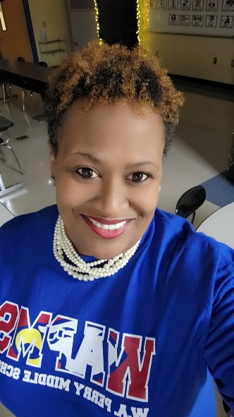

School: W. A. Perry Middle. Number of years in the UEP. Twenty-seven consecutive years of membership in the United Education Profession. Educational Background: SC State University-BS in Elementary Education; Cambridge College-M.Ed in Integrated Studies: Lesley University, M.Ed in Technology Education. Work Experience: Teacher/Technology Facilitator, W. A Perry Middle School, Richland School District One; Teacher, Winsor Elementary School, Richland School District Two; Teacher Great Falls Middle School, Chester County School District. Professional Association Memberships: The SCEA, State Delegate, Member Organizer, Building Rep.

Dr. Chastity Baccus
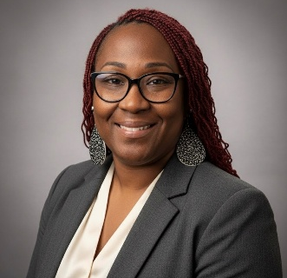

School: Mt. Gallant Elementary. Number of years in UEP. Eighteen consecutive years of membership in the UEP. Educational Background: Walden University-Doctorate Degree; Salem International University-Master’s Degree; Walden University-Master’s Degree. Work Experience: Dean of Students; 5th grade teacher; Be Great Campus Director. Professional Association Memberships: The SCEA Executive Board, York CEA Local President; NEA Leader for Just Schools
.

Dr. Clifford Joseph Lee, Jr.
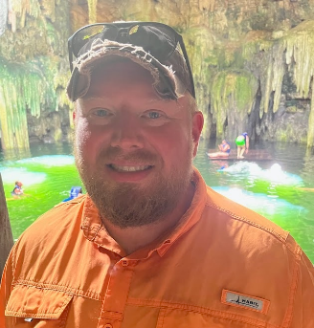

School: JL Mann High. Number of years in the UEP: Twenty consecutive years of membership in the United Education Profession. Educational Background: PhD, P-12 Educational Leadership, Clemson University; MA-Spanish Literature, The University of Akron; BA-Spanish an International, Wabash College. Work Experience: JL Mann High School, Greenville County Schools, ESOL/Spanish Teacher; Columbus Afrocentric Early College, Columbus City Schools (CCS), Spanish Teacher; The Charles School at Ohio Dominican University, CSS, Spanish Teacher. Professional Association Memberships: The South Carolina Education Association, UniDistrict 1 Director (2019-2024); The Greenville County Education Association, Vice President (2021- current); Southern Conference on Language Teaching,

Adrian Goodman
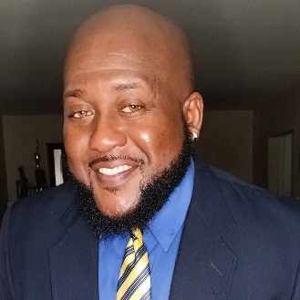

I am a 26-year special education teacher and a proud member of The South Carolina Education Association (The SCEA). Fueled by the belief that educators, when supported, can offer their best to students, I advocate for a stronger voice within the profession. As Eric Thomas says, “When you want to succeed as bad as you want to breathe, then you will be successful.” I embody this dedication by striving to create a brighter future for students through education.

James R. Fitzpatrick, Jr.
(see information under UniDistrict 2)
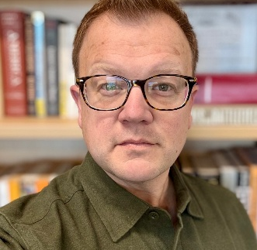

Kevin B. Trimble
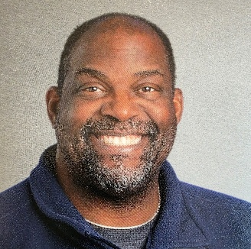

School: Reidville Elementary, Spartanburg School District 5. Number of Years in the UEP: Three years in the United Education Profession. Educational Background: Associate’s in general studies, Montgomery County Community College, Pennsylvania; Bachelor’s Degree in Sociology, West Chester University, Pennsylvania; Master’s Degree in Christian Ministries, North Grenville University, South Carolina. Work Experience: Spartanburg County District Five School; The Governor’s school for Arts and Humanities of Greenville County; Norristown Area School District, Norris, Pennsylvania. Professional Association Membership: The SCEA, Spartanburg County Education Association; participated in 2025 Election endorsement of local school board members.

Sussan Hobgood
Photo Not Available

School: Conway Middle School. Number of Years in the UEP: Three consecutive years of membership in the UEP. Educational Background: MS TESOL-Nova Southeastern University; BS in Social Work, Florida State University. Work Experience: Conway Middle School-ML teacher, 2018-present; Florida State College of Jacksonville-Adjunct Professor, ESL, 2015-2018; Reynolds Lane Elementary, Kindergarten teacher, 2007-2025, Jacksonville, FL. Professional Association Memberships: Horry County Education Association, The South Carolina Education Association, member organizer 2023-present; Member The SCEA Human and Civil Rights Committee, present.

Jean Read
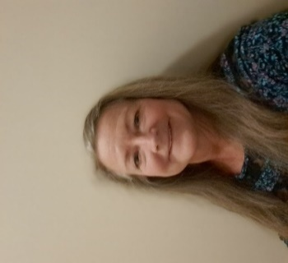

School: Horry County School District. Number of Years in the UEP: Over Thirty-seven consecutive years of membership in the United Education Profession. Educational Background: BS Early Childhood Ed, Lock Haven College, Pennsylvania. Work Experience: 2017-present substitute teacher-Horry County Schools/.Kelly Ed Services; 1987-2016-teacher 2nd-3rd grade, Evesham Twp School, NJ; 1985-1987-classroom aide, Eans Twp Schools, NJ. Professional Association Membership: 2018-present – Hoary County Education Association Vice President; 2021-present- The SCEA Board of Directors; 1985-2016-ETEA (NJEA); 1990-2016, building representative.

Roselyn Green
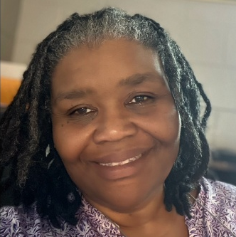

School: North Vista Elementary. Number of years in the UEP: Twenty plus years of consecutive membership in the
United Education Profession. Educational Background: Grand Canyon University; Coastal Carolina University;
Arkansas State University. Work Experience: North Vista Elementary School; H & R Block; Bank of America
Professional Association Memberships: The SCEA-Secretary Treasurer; Florence Education Association-President;
National Association of Special Education Teachers.

CANDIDATES FOR NEA DELEGATES ADMINISTRATOR
Urica M. Brown
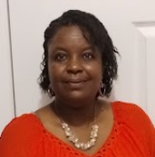

School: Andrews High. Number of Years in the UEP: Twenty-one consecutive years of membership in the UEP. Educational Background: BS in Chemistry, University of South Carolina; M.ED in Instructional Leadership, University of Phoenix. Work Experience: Instructional Coach, Andrews High School; ADEPT Facilitator, Georgetown County School District, Chemistry Teacher, Georgetown High School. Professional Association Memberships: The SCEA, District Director, UniDistrict 6; Georgetown County Education Association.

Stephanie McFadden
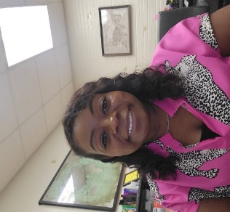

School: Bradley Elementary School. Number of Years in the UEP: Twenty-one Consecutive years of membership in the United Education Profession. Educational Background: Southern Wesleyan University-M.ED-Administration and Supervision; Southern Wesleyan University-M.ED in Elementary Education; University of South Carolina BAIS in Early Childhood and Elementary Education. Work Experience: Richland School District One – Bradley Elementary-Assistant Principal; Richand School District One-Hyatt Park Elementary-Math Interventionist; Richland School District Two -Langford Elementary-classroom teacher. Professional Association Memberships: SCASA, SCEA/RA Delegate (PAC Co-Captain); National Council of Teachers of Mathematics (NCTM).

Dr. Stephanie D. Robinson
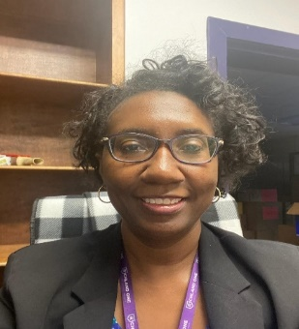

School: Waverly Administration Building. Twenty-five consecutive years of membership in the United Education Profession. Educational Background: University of Southern Mississippi Hattiesburg, Doctor of Education in Educational Administration; University of South Carolina Columbia, Educational Specialist Degree in Educational Administration.; Tuskegee University-Tuskegee, Bachelor of Arts in Language Arts Education. Work Experience: Secondary Consultant for Programs and Projects; Secondary AAP Consultant; Middle School Administrator. Professional Association Memberships: The SCEA Board of Directors; The Columbia Tuskegee Alumni Association; ZETA Phi Beta Sorority, Inc-Rho Kappa Zeta Chapter.

